BIT 4107 – Mobile Application Development
ENHANCED PROFESSIONAL STUDENT LOGBOOK
Student Name: ______John Njoroge________________________
Admission Number: BIT/2024/74648______________________________
School/Faculty: _____School of computing and infotmatics_________________________
Programme: ____Bachelor of science in information technology__________________________
Academic Year: ___________2025/2026___________________
Semester: __May/Aug 2026____________________________
Lecturer: _________Nyoro_____________________
Phone Number: ___0798740383___________________________

Instructions
This logbook is used to document weekly learning activities, practical exercises, skills acquired, challenges encountered, solutions applied, and reflections. Students should complete all sections every week.
Each week to follow remarks in week 1 section.

Autogenerated Table of content

Week 1: Introduction to Mobile Application Developmen

Practical Activities Undertaken
Studied the fundamentals of mobile development architectures.Analyzed the structural differences between native frame works and cross platform ecosystems like flutter.
screenshot
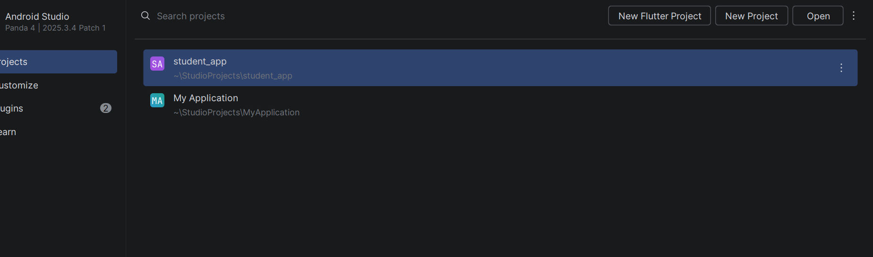

Tools/Software Used
Flutter sdk, dart sdk,android studio,git
Personal Reflection,not more than 50 words
Gained a solid understanding of how flutter compiles to native arm code,making cross platform uis highly performant

Week 2: Mobile Development Environment
Configured the local Flutter environment on Android Studio. Set up SDK paths, verified local environmental variables, and cleared environment synchronization blockers.
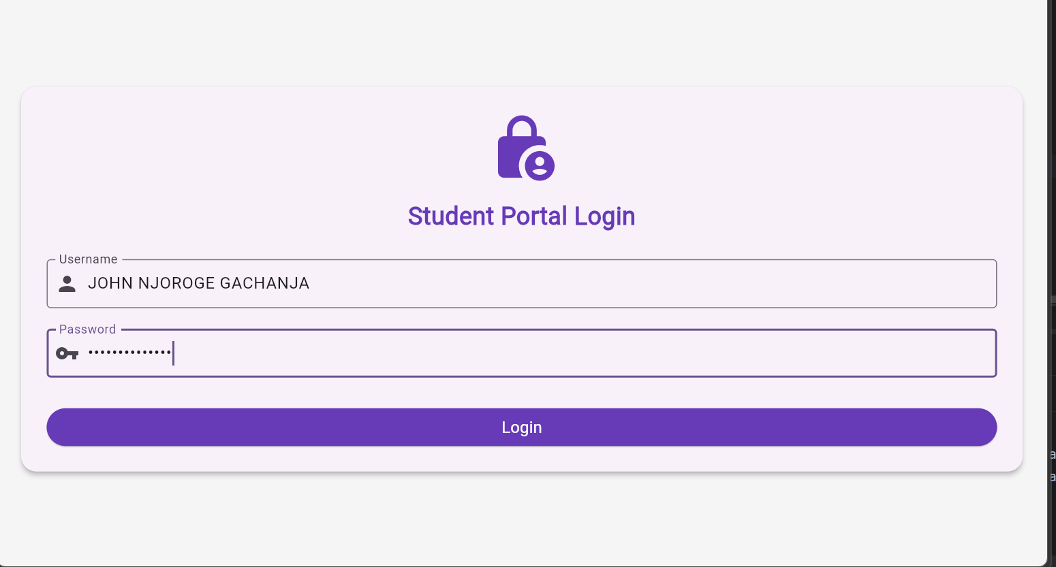
Tools/Software Used: Android Studio, Flutter SDK, Command Prompt/Terminal.
​Personal Reflection: Configuring path variables taught me how development environments communicate with the underlying operating system tools effectively.

Week 3: User Interface Design

Practical Activities Undertaken: Translated a design wireframe into clean Flutter code. Built the Vault Student Hub responsive UI layout featuring a login panel and multi-card grid dashboard.

​Screenshots/Evidence Attached: 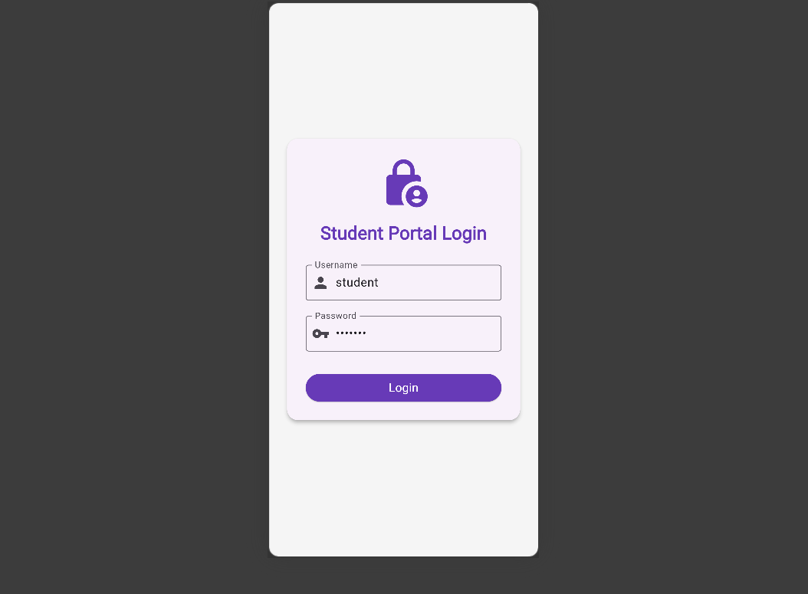
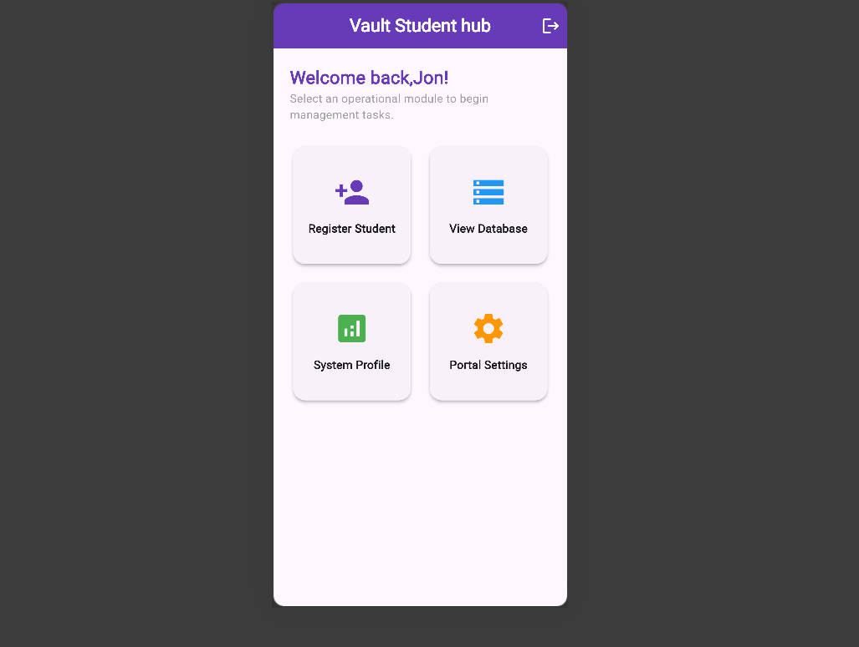
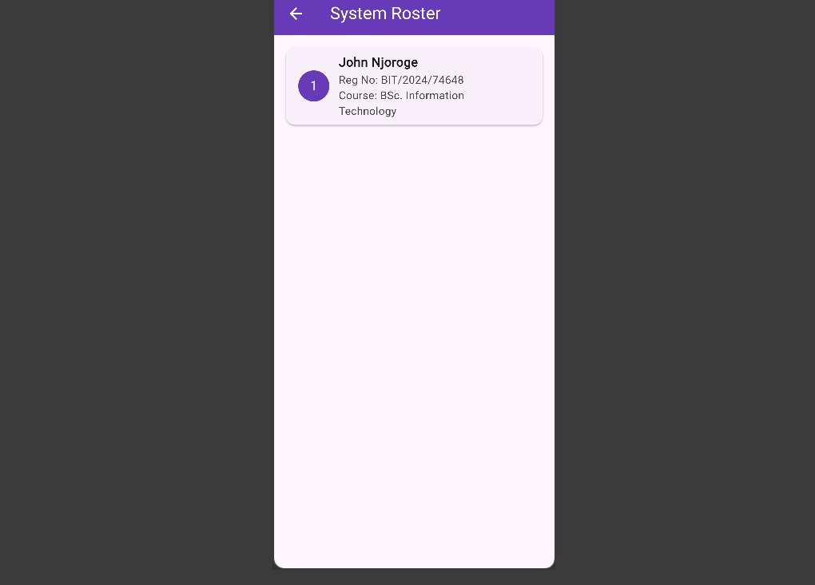

​Tools/Software Used: Android Studio, Google Edge/Chrome Web Layout Engine, Figma UI Prototype.

​Personal Reflection: Learned to utilize responsive Flutter widgets like LayoutBuilder, GridView, and custom Cards to create an adaptive application shell matching Figma layouts.

Week 4: Event Handling and User Interaction

Same as week 1

Week 5: Data Management

Same as week 1

Week 6: Networking and APIs

Same as week 1

Week 7: Application Architecture

Same as week 1

Week 8: Project Planning

Week 9: Device Features and Sensors

Same as week 1

Week 10: Notifications and Background Services

Same as week 1

Week 11: Mobile Security

Same as week 1

Week 12: Testing and Debugging

Same as week 1

Week 13: Application Deployment

Same as week 1

Week 14: Final Project Presentation

Same as week 1

Semester Project Tracking

Project Title

Project Objectives

Project Requirements

Development Milestones

Testing Results

Lessons Learned

Future Improvements

End of Semester Reflection

Summary of Skills Acquired

Most Interesting Topic

Major Challenges Faced

How Challenges Were Overcome

Professional Growth Achieved

Overall Course Experience

Final Approval
Student Name: __________________________
Student Signature: ______________________
Date: _________________________________
Lecturer Name: _________________________
Lecturer Remarks: _____________________
Date: _________________________________

